Powershell running

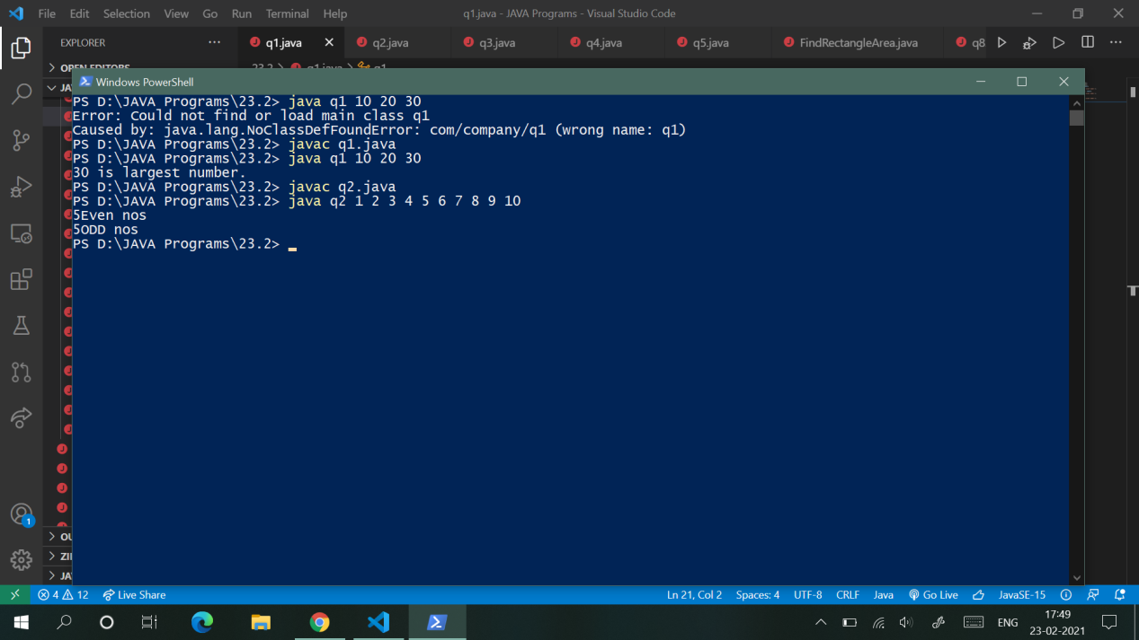

Ctrl + shift + p +right click in free space